 | Data Mining for Business Analytics  Introduction to Data Science

Homework #4

Sahil Goel
(put your name above)

Total grade: _______ out of ______ points

This assignment will give you hands-on experience in building text classification models, using the application of email spam filtering. You will use Weka to convert the textual data (emails) into feature vectors and build text mining models for automatic spam filtering. The email messages you will use were delivered to a particular server between 8 Apr 2007 and 6 Jul 2007. The target variable represents whether an email is either spam or ham (non-spam). Follow the directions and answer any questions. Your report should not be verbose, but should present your results clearly and professionally.
[Caveat: Using large sets of words, building the models and evaluating them with cross-validation requires a lot of memory. The assignment asks you to save your data files before each Weka run. You probably have increased your heapsize – see the instructions in the WEKA folder on NYClasses. If for some reason you get memory/heap errors anyway, try restarting and avoiding having any other applications open, except where indicated. If you have problems for more than 10 minutes or so, stop. Contact the TA or me--don’t spend time being frustrated with that.]
Problem 1. On NYCLasses under Data, you will find a file called spam_data_Text.arff, which contains all the emails in our dataset and is in a format ready-to-input by Weka. If you were to open this file in WordPad or some other capable text editor, you would see that each instance is just a string of the email text (between single quotes), with the target variable at the end. Thus the .arff file has two variables for each instance: the text string, and the target variable (called @class@), which takes on two values, spam and ham.
To be able to build spam filtering predictive models, we need to convert the email texts into feature vectors and engineer the features. You can do this by following the steps below:
- Load spam_data_Text.arff into Weka
- Convert the email text to word features. (In Filter: filters-->unsupervised-->attribute-->StringToWordVector). Change only two parameter settings as follows:
  - In the “tokenizer” parameter box, replace the default delimiters with the set I am providing below. You need to copy the whole thing below, including the (). You can cut and paste the string of delimiters from this document (use the Word version from NYU Classes).
(.,:;'"?!@#$%^&* {}|[]\<>/`~1234567890-=_+)
  - Set "useStoplist" to true.
Click OK and then don’t forget to click “Apply” back on the main Preprocess page!
This step splits the string into words/terms, by using the delimiters to “delimit” where words start and end. After clicking apply, it should run for a little while and then you’ll see a large set of words in the Attributes list.
- Remove non-word (noise) attributes. If you got many weird words or mixture of words and symbols, you must have wrong delimiters. Correctly applying the delimiters provided should give you fewer than 20 noisy features at the bottom of the list. Manually remove those features [check the boxes in Attributes and click Remove].
- Binarize the features (meaning, change them from numeric features to 1 for “the word is present in this email” or 0 for “the word is absent”). (In Filter: filters-->unsupervised-->attribute-->NumericToBinary) [click Apply!] [If the last attribute, “zip”, remains unbinarized, just remove it.]
- Randomize the instances. (In Filter: filters-->unsupervised-->instance-->Randomize) [click Apply!]
- Save the data you just engineered as spam_data_ Occurrence.arff by clicking the “save” button at the upper right.
Now you are just about ready to build text classification models. Go to the “Classify” tab. First select @class@ as the target variable from the pull-down list in the rectangle under the “More options” button. Then choose as your classifier Naïve Bayes (classifiers→bayes →NaiveBayes ). If NaïveBayes is greyed out, make sure you selected the right variable as the target variable (in the box below “More options”).
Report the evaluation results of your model using 10-fold cross-validation. Consider it both as a model that ranks cases by the likelihood of class membership and in the final use as a classifier that automatically moves some of your mail to the SPAM filter. Observe that the default cutoff for the classification performance will be at 0.5. Think about your own email use – what metrics from the confusion matrix is most important to you?
Report your results below on this page. Feel free to add more pages if one page is not enough for your results.

Time taken to build model: 0.6 seconds

=== Stratified cross-validation ===
=== Summary ===

Correctly Classified Instances 7972 98.2984 %
Incorrectly Classified Instances 138 1.7016 %
Kappa statistic 0.9644
Mean absolute error 0.0178
Root mean squared error 0.1224
Relative absolute error 3.7142 %
Root relative squared error 24.9783 %
Total Number of Instances 8110

=== Detailed Accuracy By Class ===

TP Rate FP Rate Precision Recall F-Measure ROC Area Class
0.995 0.035 0.977 0.995 0.986 0.997 ham
0.965 0.005 0.992 0.965 0.978 0.998 spam
Weighted Avg. 0.983 0.023 0.983 0.983 0.983 0.998

=== Confusion Matrix ===

a b <-- classified as
4838 26 | a = ham
112 3134 | b = spam

I think what is more important to users is false positive i.e. which are ham but classified as spam. This should be as low as possible. A user won’t mind one or two more spams in inbox but if an important email goes to spam, the user might not want that. Also, Hams, which are classified as Ham, should be higher.

If we can decrease a margin from .5 to something like .40 for classifying it as HAM, we might get rid of those false positives.

Problem 2. The spam filtering model you just built is based on word occurrence (presence or absence) in a document. Now let’s use the frequency of each word in the document instead. Repeat the above step 1 from the original data file. In step 2, in addition to changing the two parameters, set outputWordCounts to true. Then apply step 3 and 5, skipping steps 4 and 6. Save your data as spam_data_ Count.arff.
Now you can build a classifier using NaïveBayesMultinomial, a version of NaiveBayes taking into account multiple occurrences of a word (classifiers→bayes →NaiveBayesMultinomial) to build your prediction model. Report the 10-fold cross-validation results and compare with the occurrence-based results in the previous question.
Report your results below on this page. Feel free to add more pages if one page is not enough for your results.
Time taken to build model: 0.03 seconds

=== Stratified cross-validation ===
=== Summary ===

Correctly Classified Instances 7956 98.1011 %
Incorrectly Classified Instances 154 1.8989 %
Kappa statistic 0.9602
Mean absolute error 0.0205
Root mean squared error 0.1237
Relative absolute error 4.2714 %
Root relative squared error 25.25 %
Total Number of Instances 8110

=== Detailed Accuracy By Class ===

TP Rate FP Rate Precision Recall F-Measure ROC Area Class
0.996 0.041 0.973 0.996 0.984 0.997 ham
0.959 0.004 0.993 0.959 0.976 0.998 spam
Weighted Avg. 0.981 0.026 0.981 0.981 0.981 0.998

=== Confusion Matrix ===

a b <-- classified as
4843 21 | a = ham
133 3113 | b = spam

=== Detailed Accuracy By Class ===

TP Rate FP Rate Precision Recall F-Measure ROC Area Class
0.996 0.041 0.973 0.996 0.984 0.997 ham
0.959 0.004 0.993 0.959 0.976 0.998 spam
Weighted Avg. 0.981 0.026 0.981 0.981 0.981 0.998

=== Confusion Matrix ===

a b <-- classified as
4843 21 | a = ham
133 3113 | b = spam

Second model is better wrt false positives.

Problem 3. In class we spent repeatedly a lot of time discussing the notion of a cutoff to make a decision and the fact that 0.5 is not necessarily the most appropriate. The confusion matrices that Weka provides use this cutoff as default. Discuss briefly whether you believe this decision rule--specifically this threshold of 0.5--is appropriate for this application; if so, why exactly? If not, why not?
Build a model in Weka using 34% of the data as test data. Compute the confusion matrices for two different thresholds, one higher than 0.5 and one lower than 0.5, and report the results. Choose a threshold that would make sense to you (possibly 0.5) and explain why briefly, comparing the results for the different thresholds. [NB: You probably will want to take the predictions out of Weka and process them yourself in Excel. You'll need to figure out how to use the model output probabilities and actual labels to construct a confusion matrix with a different threshold.]
Report your results below on this page. Feel free to add more pages if one page is not enough for your results.
Though .5 cutoff here gives good results but there might be a couple of things to consider:-
(1). Base rate:- If base rate is not approx. 50%, we might need to change the threshold to take that into effect.
(2). Reducing False positives:- As I mentioned above, we need to reduce false positives(i.e. Hams which are identified as Spam). User might manage with one or two spams in his/her inbox, but an important email in spam might be unacceptable. To do this we must decrease threshold to say .40(for Ham)(Everything with >.40 probability for HAM will be HAM) and (.60)(Everything with >.60 probability for Spam will be spam) for Spam that is, it is more probable for an email to be a ham so as to reduce false positives.

There are 5 graphs below with respect to various parameters v/s threshold (for classifying it as Ham.

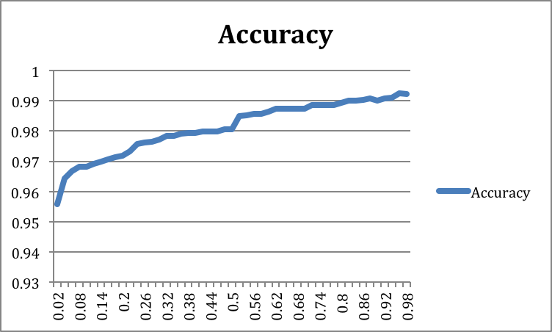

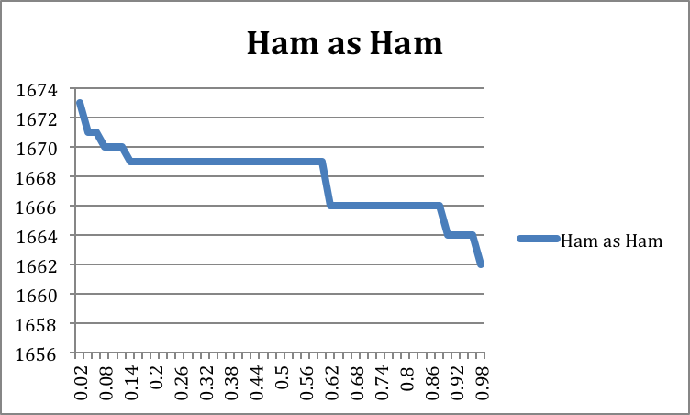

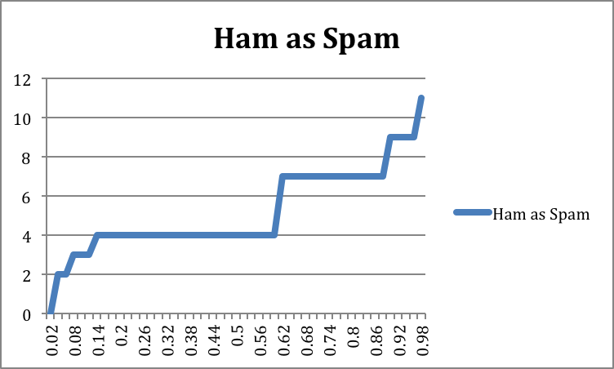

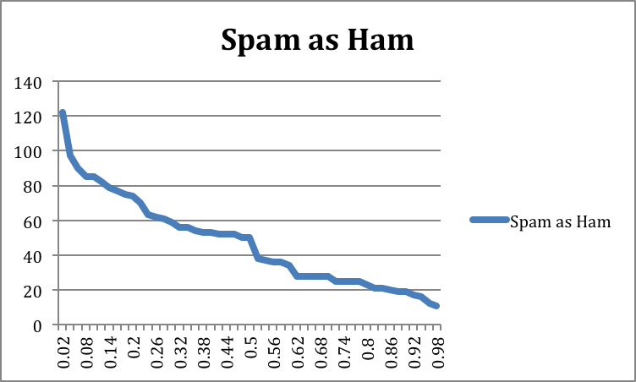

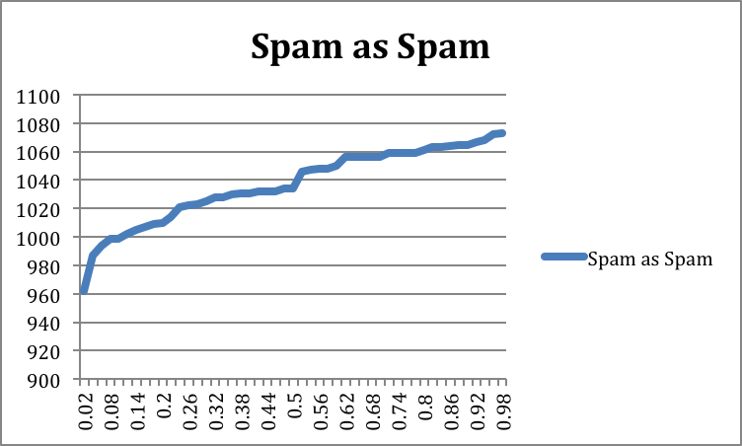

At threshold .5
=== Confusion Matrix ===
a b <-- classified as
1669 4 | a = ham
38 1046 | b = spam
Accuracy: 98.04

At threshold .4
=== Confusion Matrix ===
a b <-- classified as
1669 4 | a = ham
53 1031 | b = spam
Accuracy: 97.932

At threshold .6
=== Confusion Matrix ===
a b <-- classified as
1669 4 | a = ham
34 1050 | b = spam
Accuracy: 98.62

Decision: Though accuracy at threshold of .6 is more than accuracy at threshold .4, I would still go for threshold of .4, because in a large test set, there will be a fewer hams now, which are classified as Spams and I think that is an important feature.

ONLY FOR THIS TEST SET: If we consider only this test set: Then I would go for threshold of .6 because false positives are constant till .6 and after that it increases. Also Accuracy is increasing wrt to threshold.

